**The Mystery of the Skulls: What Old Bones Can Tell Us About Hominins**



This lab has been adapted from the Cornell Institute for Biology Teachers

**Hominin Skulls**

**Page 1**

In this laboratory activity, you and your investigative team will examine 8 skulls to expose the secrets of how these species lived. In a CSI-type analysis, your team will collect and compare data that will enable you to unlock the mystery of the relatedness of these species.

**Introduction**

When scientists discover an organism, whether it is a fossil or a living species, they set out to determine whether this organism is a new species or one that has already been described. With living, or recently dead specimens, this task is reasonably easy because usually an entire body is found, or because DNA analysis can be used to compare the specimen to other known species.With fossils, the task is much more difficult because most of the time only a skull, a fragment of a skull, or some other part of the body is found. Scientists must then determine how similar or different it is to species that are already described. In some cases, the differences are so significant that they cannot be explained as individual differences or differences between the sexes. In these cases, scientists decide that they have found a new species. From here, again they make comparisons to other described species to decide how to classify their new discovery. Organisms that are similar to those already described would be placed in the same genus, while those that are very different would be classified in a different genus, or even a different family within the accepted classification system.

The study of human origins is known as **paleoanthropology**. Paleoanthropologists have found about 20 extinct species that are closer to humans than to other primates such as chimpanzees, gorillas, baboons, and macaques. These species are known as **hominins**. The older synonym **hominid** is still used in some textbooks, but this term is more broad and refers to all current and extinct great apes (including humans, gorillas, orangutans, and chimpanzees). Among hominins, skulls of different species have specialized features that are used to classify them. These features include, among others:

1. the presence or absence of a **brow ridge**,

2. **cranial capacity** (the volume of the braincase),

3. the placement of the **foramen magnum** -the hole in the underside of the skull through which the spinal cord attaches to the brain.

In this lab you will examine the same features that scientists do in 8 skulls. These features will help you to determine how closely related the species (some that are extinct and some that are not) are to each other.

Furthermore, from examining skulls you will learn information about how the organism lived such as whether the species walked on 2 legs (bipedal) or 4 legs (quadrupedal).

**Procedure Part I: *Collecting Your Data***



**S**

**R**

**L**

**P**

**Hominin Skulls**

**Page 2**

Your classroom will be set up into workstations through which you and your team will rotate. At each station there will be 2 skulls, and you will make observations and measurements that you will record and use later to determine the identity and relatedness of these specimens. Once finished, you will be asked to graphically represent the time during which each of the hominins lived. You will have approximately 10 minutes at each station during which to make your observations and measurements OR to make your graph.

Look for the letter codes written on the underside of each skull. Your investigative team’s mission is to identify each skull with its proper scientific name and figure out how it is related to the other skulls.

Skulls found at 4 workstations (if your group is not at a station get started on your Geological Time Scale – Page 8):

**Station 1 Station 2 Station 3__________Station 4**

**E H B G**

At **Stations 1** – **4**, you will be presented with 2 skulls at a time and should fill out **Table 1** by looking at one feature at a time. When you are examining the skulls, you should collect the data to complete the following (Make sure that you record your data in the row that corresponds to the particular skull that you are examining**)**: WE WILL BE TAKING CLASS AVERAGES.

**1. FL** - Forehead Length:The forehead is roughly the area from the top of the eye socket to the part of the skull that begins to flatten (the hairline). Look at the front of the skull and determine if the forehead is Long (L) or Short (S). Visualize your own forehead and imagine the part between your eyebrows to where your hairline begins - If this length is at least 2 inches, we consider it to be Long (L).

**2. SC** - Sagittal Crest:A sagittal crest is a ridge of bone that protrudes from the skull and runs on top of the skull from front to back. Look at the top of the skull and determine if a sagittal crest is present (+) or absent (-).

**3. BR** - Brow Ridge:A brow ridge is a bone that runs the entire width of the skull just above the eyes. Look at the front of the skull and determine if a brow ridge is present (+) or absent (-).

**4. P/S** - Prognathism/Snout:Prognathism refers to the protrusion of the mouth from the front of the skull. Animals with prognathism are thought of as having a ‘snout’. To determine if a skull exhibits prognathism, press your fingers along the base of the nose opening (Anterior Nasal Spine) and rest it on the top of the maxilla (where the top teeth attach). If this area is greater than 1 index finger in width, then we consider the skull to exhibit prognathism. Record (+) if the skull exhibits prognathism or (-) if the skull does not exhibits prognathism.

**5. CL** - Canines Long (and sharp):The canines are sometimes referred to as ‘fangs’. They are the third pair of teeth from the front – in your mouth, your 2 front teeth and the next one in each direction are called ‘incisors’. The next tooth on either side is slightly pointy and called ‘canine’, but in many animals, like dogs and cats, these canines are very long and sharp. If the canines are not present in the skull, the cell in the table has been blackened out. If you notice that the canines are ‘fang-like’, we consider them to be long and sharp (+) if not fang-like mark (-).

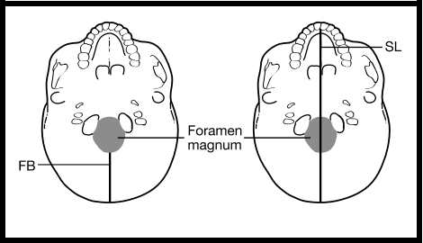

**Hominin Skulls**

**Page 3**

**6. FB** - Foramen Magnum Distance to Back (mm):Look at the underside of the skull and determine the distance between the foramen magnum and the back of the skull, measured in mm). The foramen magnum is the hole in the skull through which the spinal cord attaches to the brain. To determine

this distance, place a ruler on the base of the skull, starting at the back most edge of the foramen magnum and measure the distance to the end of the skull (see diagram below).

**7. SL** - Skull Length (mm):Look at the underside of the skull and determine the length of the skull (measured in mm). Place a ruler on the base of the skull (see diagram above) and measure the distance from the back of the skull to the end of the palate (roof of the mouth).

**8. FMI** - Foramen Magnum Index:Calculate the ratio using the Foramen Magnum Distance to Back (FB) and the Skull Length (SL). To do this for each skull, divide the value that you recorded for FB by the value that you recorded for SL, and fill in the corresponding box to the 3rd digit after the decimal point.

**9. CCC** - Cranial Capacity:Look at the skull from the top and sides and estimate the number of average fists that would fit inside the cranium (the area of the skull where the brain is located). For these skulls, limit your estimate to 2, 3 or 4 ‘fists’.Now, multiple that number by 300. This is your **CCC** value!

**10.Cranium Shape** –Look at each skull from the top. Specifically, look at the shape of the cranium (the part of the skull where the brain is located). If the shape is boxy, we consider it to be Cuboid (C). In other words, it more closely resembles that of a box than that of a ball. If the shape is rounded, then we consider it to be Spheroid (S). In other words, it more closely resembles that of a ball than that of a box.

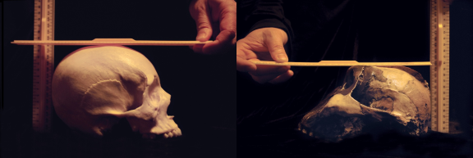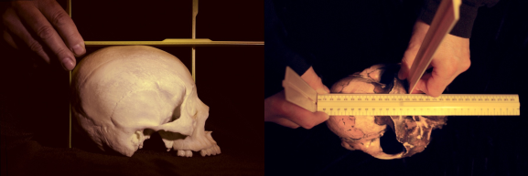

**Hominin Skulls**

**Page 4**

*All of the measurements below should be taken with the top of the skullfacing upwards (natural resting position).*

**11. Length of the braincase (L):** Position three rulers as shown on the left side of the photograph below. Ruler 1 should stand perpendicular to the table, and rest at the back of the skull. Ruler 2 should also stand perpendicular to the table, but rest on top of the skull, just behind the brow ridge. If a brow ridge is not present, align the ruler against the forehead in the same perpendicular orientation (imagine it flat against your forehead). Ruler 3 should rest on the highest point of the cranium, making sure that it is parallel with the table. Once all 3 rulers are in place, read the distance on ruler 3 between the 2 upright rulers in mm (see the right side of the photograph below). Record your data in the first column labeled “L”.

*Skull length measurements for two different species: View from the side (left), view from the top (right).*

**12.Height of the braincase (H):**Without moving the 3 rulers from your measurement of Length, read the height of the skull off ruler 1 (at the back of the skull) in mm (also see photographs below). Record your data in the first column labeled “H”.

*Skull height measurement: view from the side for two different species. Note: upright ruler in the front of skull is removed.*

**13.Width of the braincase (W):** Position 3 rulers as shown in the photographs below. Rulers 1 and 2 should stand perpendicular to the table and flat against the skull (imagine 2 rulers flat against where the ears would be positioned). Position ruler 3 resting on the top of the skull, making sure that it is parallel with the table. Read the distance between rulers 1 and 2 in mm. Record your data in the first column labeled “W”.

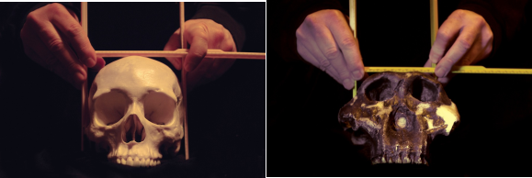

**Hominin Skulls**

**Page 5**

*Skull width measurement for two different species with the three rulers perpendicular to each other. Note the placement of the upright rulers on the sides: for the species on the right photograph, the rulers are not at the widest point of the skull (the* ‘*zygomatic arc*h’ *or cheek bone), but at the widest point of the braincase further back.*

**ONCE TABLE 1 IS COMPLETE: ENTER YOUR DATA INTO THE CLASS EXCEL SHEET AT THE FRONT OF THE ROOM.**

**From your data we will calculate class averages for:**

**ASV** - Approximate Skull Volume:calculated as the product of AVG L, AVG H, and AVG W, and divided by 1000.

**ESV** - Estimated Skull Volume:the measurements that you took of the skull will overestimate the cranial capacity because skulls are not cubes. To correct this, you should divide the number that you calculated in the previous column (ASV) by 2 for species S, N, E, G and H, and by 3 for all other species (A, B, K and L). You use a different correction factor for each group of skulls because the skull shapes vary between species.

**FMI** – Average from class data.

**Hominin Skulls**



**Page 6**



|  |  |  |  |  |  |  |  |  |  |  |  |  |  |
| --- | --- | --- | --- | --- | --- | --- | --- | --- | --- | --- | --- | --- | --- |
|  |  |  |  |  |  |  |  |  |  |  |  |  |  |
|  |  |  |  |  |  |  |  |  |  |  |  |  |  |
|  |  |  |  |  |  |  |  |  |  |  |  |  |  |
|  |  |  |  |  |  |  |  |  |  |  |  |  |  |
|  |  |  |  |  |  |  |  |  |  |  |  |  |  |
|  |  |  |  |  |  |  |  |  |  |  |  |  |  |
|  |  |  |  |  |  |  |  |  |  |  |  |  |  |
|  |  |  |  |  |  |  |  |  |  |  |  |  |  |
|  |  |  |  |  |  |  |  |  |  |  |  |  |  |



**Table 2 Class Average Values**



**Page 7**

|  |  |  |  |  |  |  |  |  |  |
| --- | --- | --- | --- | --- | --- | --- | --- | --- | --- |
| **Skull**  **Letter**  **Code** | **Class**  **AVG**  **FB** | **Class**  **AVG**  **SL** | **Class AVG FMI (AVG FB/AVG SL)** | **Class AVG L (mm)** | **Class AVG W (mm)** | **Class AVG H (mm)** | **ASV (LxWxH/1000) (cm3)** | **ESV (cm3)** | **Class**  **AVG**  **FMI** |
| **S** |  |  |  |  |  |  |  |  |  |
| **E** |  |  |  |  |  |  |  |  |  |
| **R** |  |  |  |  |  |  |  |  |  |
| **H** |  |  |  |  |  |  |  |  |  |
| **L** |  |  |  |  |  |  |  |  |  |
| **B** |  |  |  |  |  |  |  |  |  |
| **P** |  |  |  |  |  |  |  |  |  |
| **G** |  |  |  |  |  |  |  |  |  |

**Hominin Skulls**

**Creating a Geological Times Scale**



|  |  |  |  |  |  |  |  |
| --- | --- | --- | --- | --- | --- | --- | --- |
| 0.16 to 0 |  |  |  |  |  |  |  |
| 0.7 to 0.3 |  |  |  |  |  |  |  |
| 1.8 to 0.2 |  |  |  |  |  |  |  |
| 1.9 to 1.5 |  |  |  |  |  |  |  |
| 2.3 to 1.2 |  |  |  |  |  |  |  |
| 4.0 to 2.7 |  |  |  |  |  |  |  |
| 6.0 to 0 |  |  |  |  |  |  |  |
| 7.0 to 0 |  |  |  |  |  |  |  |



**Hominin Skulls**

**Page 8**

You will be asked to graphically represent the time during which each of the hominins lived.

To create a geological time scale: Shade the following time periods on each bar of the graph starting with the top one. Remember 0 years = present timeLater, we will match the skulls to these time periods.

|  |  |
| --- | --- |
| (I) (II) (III) (IV) (V) | 160,000 years ago to present 700,000 to 300,000 years ago 1.8 to 0.2 mya  1.9 to 1.5 mya  2.3 to 1.2 mya |

(VI) 4.0 to 2.7 mya (VII) 6.0 mya to present (VIII) 7.0 mya to present

**I**

**II**

**III**

**IV**

**V**

**VI**

**VII**

**VIII**

7 mya 6 mya 5 mya 4 mya 3 mya 2 mya 1 mya 0 mya

**Geological Time Scale (mya)**

Each Roman numeral represents the time period for one of the 8 skulls.Think of each time period as a fossil layer in which a skull was discovered.From a collaborating lab that performs radiometric dating of fossils, you received the age of each of the fossil layers (I through VIII), and will later pair these ages up with the identity of the skulls found in these layers.

As an investigator, you will want to establish the relationship between these layers and the corresponding skulls to determine the time intervals during which each species lived, and possibly coexisted with others. Remember, not all fossils were found in the same location, or even the same continent. You will eventually place this information in a phylogenetic tree that shows the relatedness of these and other hominin species.

**Your TA will provide you with the Skull Letter Codes that correspond to each time period in your geological time scale graph.** You should thenwrite the single letter code for each skull in the area that you shaded within the Geological Time Scale graph above.

Discuss in class: Which time interval has the greatest number of hominin species coexisting?

**Procedure Part II: *Foramen Magnum Index Comparison***

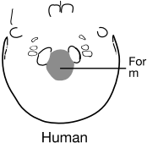

|  |  |
| --- | --- |
|  |  |
|  |  |
|  |  |
|  |  |
|  |  |
|  |  |
|  |  |
|  |  |
|  |  |
|  |  |

|  |  |
| --- | --- |
|  |  |
|  |  |
|  |  |
|  |  |
|  |  |
|  |  |
|  |  |
|  |  |
|  |  |
|  |  |

|  |  |
| --- | --- |
|  |  |
|  |  |
|  |  |
|  |  |
|  |  |
|  |  |
|  |  |
|  |  |
|  |  |
|  |  |

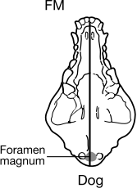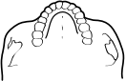

E



**Hominin Skulls**

**Page 9**

As scientific investigators, you will now begin to compare the data that you have collected from different skulls. Specifically, you will put some of your Class FMI data onto a graph in order to compare them to each other.

The location of the foramen magnum in the skulls will reveal some interesting information about the way that the hominins lived. **The FMI is an indicator of the location of the foramen magnum on the underside of the skull. The closer to 0.3 the FMI of a species is, the better adapted they were to upright/bipedal walking.** In order to visualize any trends in the location of the foramen magnum among the hominin skulls, you will enter the Class FMI for the 4 skulls (L, H, R, E) on the Foramen Magnum Index graph (see below). Determine the FMI for dog (a quadruped) and human (a biped) using the scales provided. Focus on the bottom end of the foramen magnum, which is labeled for these two species and write this number on the line above the diagrams of these 2 skulls.

|  |  |
| --- | --- |
|  |  |
|  |  |
|  |  |
|  |  |
|  |  |
|  |  |
|  |  |
|  |  |
|  |  |
|  |  |

R

**Procedure Part III: *Analyzing Your Data***



**Page 10**

In order to determine whether a relationship exists between the Foramen Magnum Index and Cranial Capacity, you will plot these two parameters for each species in the provided FMI-Cranial Capacity graph below. For this you need to first complete Table 3 using the Class FMI and the provided Average Cranial Capacity provided (ACC- sometimes called Actual Cranial Capacity).

The Average Cranial Capacity for each skull is based on scientists’ measurements of several fossils. Your calculated estimates of cranial capacity (CCC, Table 1) likely over- or under-represented the true cranial capacity.

***Table 3***

|  |  |  |
| --- | --- | --- |
| *Skull Letter Code* | *Actual Cranial Capacity (ccm)* | *Avg FMI (from class data)* |
| S | 1400 |  |
| E | 1025 |  |
| R | 900 |  |
| H | 1280 |  |
| L | 463 |  |
| B | 525 |  |
| P | 400 |  |
| G | 500 |  |
| M |  |  |

Questions to discuss in class:

1. Why is the class FMI usually a better indicator of the location of the foramen magnum than your individual calculation?

2. Compare the data that you calculated for cranial capacity (CCC) to the Actual Cranial Capacity (ACC), which of your calculations have most likely overestimated the cranial capacity?

3. What could you do to get your Calculated Cranial Capacity value closer to the actual value?

4. After measuring the skull volume using rulers, you applied a correction factor to arrive at your ESV.

*a.* Why was a correction factor necessary?

*b.* Why was a different correction factor used for different groups of species?

**Hominin Skulls**

You will notice that there is a new Skull Letter Code “M” in Table 3. This “M” is also the only data point already filled in on the FMI-Cranial Capacity graph and represents the macaque, an old-world monkey species that is quadrupedal. From this data point “M” you can determine the macaque’s Average Cranial Capacity and FMI and add them to Table 3.



**Page 11**



|  |
| --- |
|  |
|  |
|  |
|  |
|  |
| •M |
|  |



200

1200

1400

400 600 800 1000

**Average Cranial Capacity (ccm)**

1600

After completing Table 3, plot the values and write the Skull Letter Code next to each data point in the graph below. **Do not connect the dots with lines.** Instead, once you have plotted the points for all of the skulls, you should draw a “best-fit curve”. Ask your TA if you do not know how to draw a line of ‘best fit.’ While there is a way to mathematically determine the location of such a curve, you can estimate it by visualizing the sum of the distances from each point above and below the curve. These 2 sums should be approximately the same.

Excluding the macaque M, group the 8 species into 3 clusters of two or more points that are near each other. Draw a circle around each cluster and list the letters for each of these clusters.

***FMI-Cranial Capacity graph***

**FMI**

0.35

0.3

0.25

0.2

0.15

0.1

0.05

0

0

**Hominin Skulls**

**Questions on *FMI-Cranial Capacity graph***



**Page 12**

1. Compare your first cluster (closest to M) with data point M (macaque), which variable accounts for the major difference between them, FMI or Cranial Capacity?

2. Compare the middle cluster to cluster 1, which variable accounts for the major difference between them, FMI or Cranial Capacity?

3. Compare the final cluster to the middle cluster , which variable accounts for the major difference between them, FMI or Cranial Capacity?

4. Using the Geological Time Scale graph as a reference, list the three clusters in order of their relative age:

cluster #___ is older than cluster #___, which is older than cluster #___

5. As you go from oldest to most recent cluster of hominin species, which factor (FMI or Cranial Capacity) changed more?

**Part IV: *Putting It All Together***

In this final part of the investigation you will combine your results with data that other scientists have already collected. Specifically your goal is to complete a phylogenetic tree that shows how all these hominins are related to each other and how paleanthropologists concluded that they have evolved. This phylogenetic tree contains many more species than the 8 that you have been studying. In this phylogenetic tree all the hominins are already correctly placed regarding their ages, and they are labeled with their scientific names. Your task is to fill in the Skull Letter Codes from your 8 skulls into the correct gray squares that are drawn next to some of the hominins using the information that you gathered in your studies.

**DO NOT INCLUDE SKULLS P AND G IN THIS PHYLOGENETIC TREE. THESE SPECIES SHARE A COMMON ANCESTOR WITH HOMININS 6.0 AND 7.0 MYA, RESPECTIVELY. They are not hominins, they are hominids.**

Tip: the biggest help for this undertaking is most likely the age of the fossil species (see time axis on each side of the tree). Both the solid and stippled parts of the bars next to the skull sketches indicate the time period during which the species lived.

**Hominin Skulls**

Other characteristics, especially skull shape, should also be taken into account when making your final determination. Once you have completed filling in the gray squares, you should write the names of the 8 skulls in Table 1. Use the space in the Skull Letter Code column.



**Page 13**

Check with your TA to see if you have correctly named the skulls! If so, congratulations – you solved the mystery!

**Hominin Skulls**

*Australopithecus*



**Page 14**

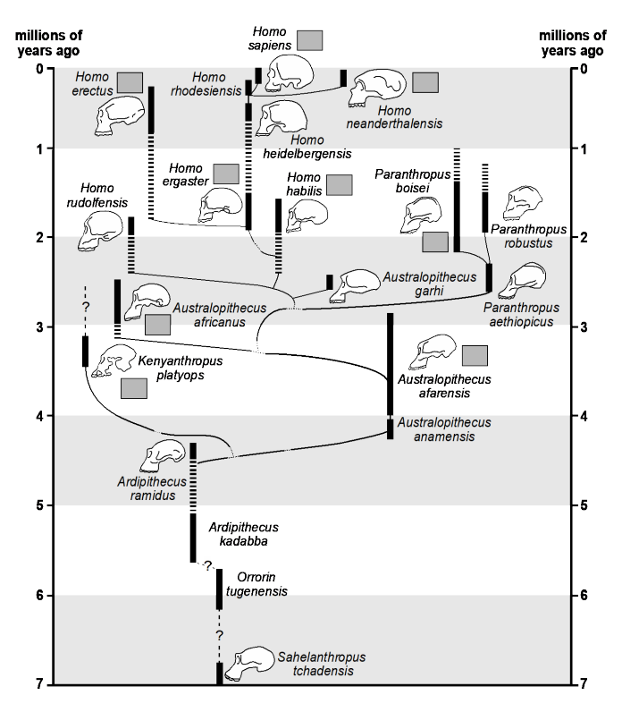

**Phylogenetic Tree**

**Hominin Skulls**